Aror University of Art, Architecture, Design & Heritage Sukkur

Department of AI-Multimedia and Gaming.

Lab 01: Fundamentals of Linked List data structure.

Subject: Data Structure (CSC221), Fall 2024 Date: Sep 10, 2024

Instructor: Abdul Ghafoor Lab objectives:

Objective: To practice and understand the basic operations in a singly linked list, including insertion, deletion, Searching, and traversal of nodes.

Lab Part 01.

|  |  |
| --- | --- |
| Name: Shafique Ahmed | Roll no: ARI-F23-0052 |
| Subject: DSA | Submitted to: Sir Abdul Ghafoor |

GitHub Link for lab task 1:

<https://github.com/Shafique-Ahmed-52/DSA-LAB3-TASk1.git>

LAB part 2:Leet Code:

Task1: <https://leetcode.com/problems/intersection-of-two-linked-lists/description/?envType=problem-list-v2&envId=linked-list>

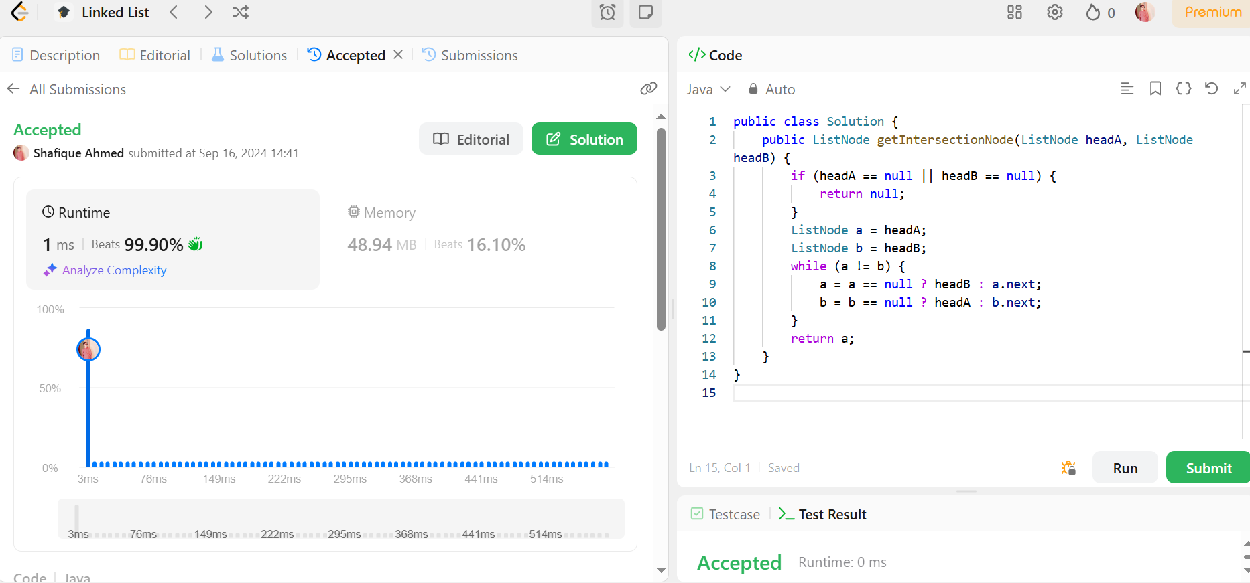

Task2: <https://leetcode.com/problems/remove-duplicates-from-sorted-list/description/?envType=problem-list-v2&envId=linked-list>

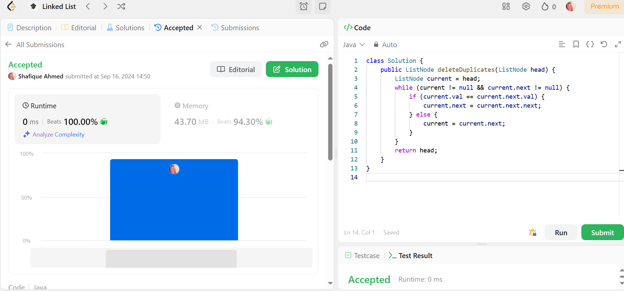

Task3: <https://leetcode.com/problems/merge-two-sorted-lists/description/?envType=problem-list-v2&envId=linked-list>

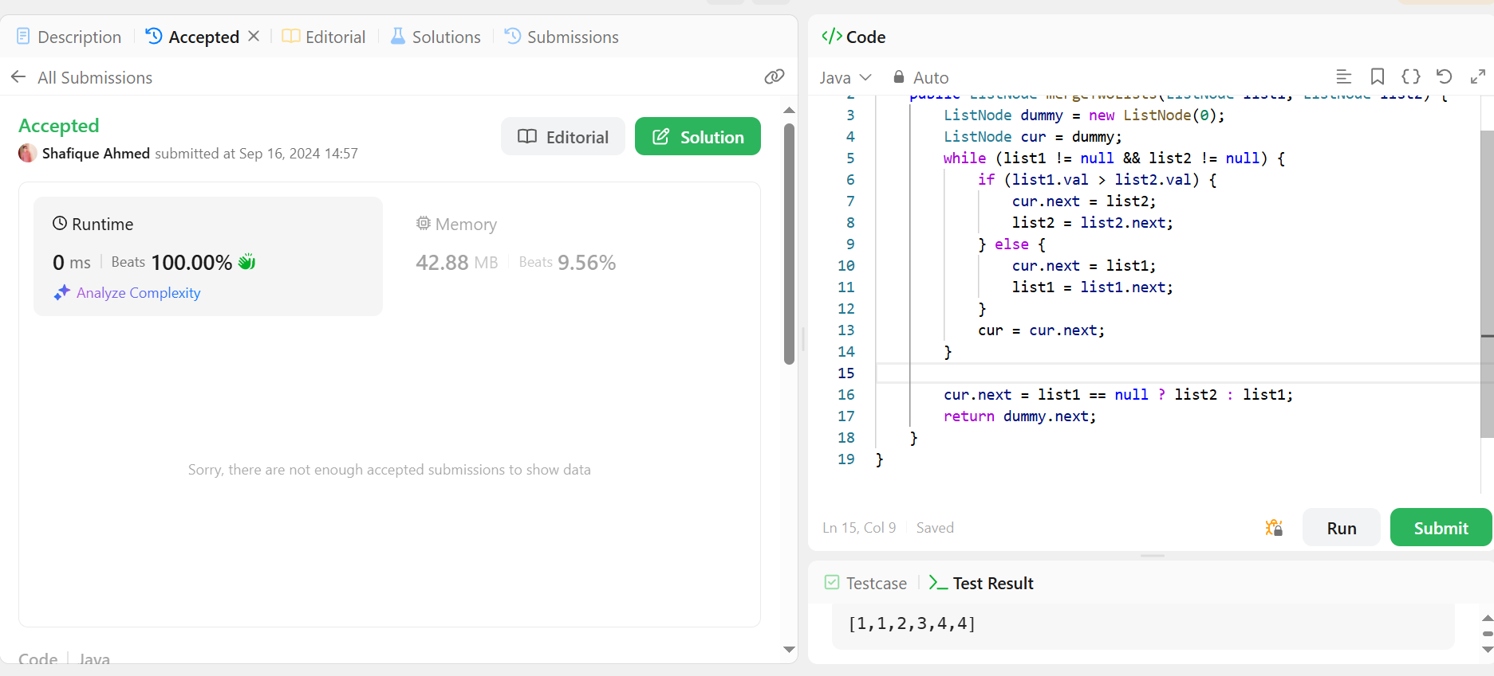

Task4: <https://leetcode.com/problems/add-two-numbers/description/?envType=problem-list-v2&envId=linked-list>

